Client Name: |  |  |  |  | Date:

Address:

Reason for Visit: ☐ Initial Home Assessment ☐ Chronic Disease Check-In ☐ Medication Check-In ☐ Resource Coordination

Barriers Identified Prior to Visit:

Medicaid Reimbursement Qualifying Barrier(s): (Please check all that apply, if applicable)

___ Geographic Distance from health services

___ Lack of phone (Seeking care at incorrect location)

___ Cultural/language communication barriers

___ Other: _____________________________________

SCENE SAFETY
- Share your destination/address with a colleague.
- Make your expectations clear when entering the home.
- Ask who else is in the home during your visit?
- When assessing the home check to see if there are any weapons or dangerous items present.
- Check for any drugs or dangerous chemicals present.
- Look for any obstacles that could impede your exit in case of an emergency.
- Are there any pets in the home? If so, where are they currently?

GENERAL INFORMATION GATHERING

What is your current Gender Identity? Preferred Pronoun? ☐ He/Him/His ☐ She/Her/Hers ☐ They/Them/Their ☐ Other

Are you currently Employed? Place of Employment? Main Source of Income?

Are you a Refugee? Preferred Language: Ability to Read and/or Write?

Preferred Method of Learning: ☐ Verbal Education/Instructions ☐ Written Education/Instructions ☐ Visual Demonstration (Teach Back Method)

What kind of Insurance do you have? ☐ None/Self Pay ☐ Medicaid ☐Medicare ☐ Private Payor

SOCIAL DETERMINANTS OF HEALTH

FAMILY & HOME
- HOW MANY FAMILY MEMBERS, INCLUDING YOURSELF, DO YOU CURRENTLY LIVE WITH?
- ARE YOU WORRIED ABOUT LOSING YOUR HOUSING?

RESOURCES
- IN THE PAST YEAR, HAVE YOU OR ANY FAMILY MEMBERS YOU LIVE WITH BEEN UNABLE TO GET ANY OF THE FOLLOWING WHEN IT WAS REALLY NEEDED?
  - FOOD
  - CLOTHING
  - UTILITIES
  - CHILD CARE
  - PHONE
  - MEDICINE
    - DO YOU CURRENTLY TAKE ANY MEDICATIONS?
    - WHEN IS THE LAST TIME THEY WERE REFILLED?
      - WHICH PHARMACY?
  - ANY HEALTH CARE (MEDICAL, DENTAL, MENTAL HEALTH, VISION)
    - LAST MEDICAL VISIT:
    - LAST DENTAL VISIT:
    - LAST MENTAL HEALTH VISIT:
    - LAST VISION VISIT:
    - HOSPITALIZED IN LAST 6 MONTHS?
    - EMERGENCY DEPARTMENT VISITS IN LAST 6 MONTHS?
- HAS LACK OF TRANSPORTATION KEPT YOU FROM MEDICAL APPOINTMENTS, MEETINGS, WORK, OR FROM GETTING THINGS NEEDED FOR DAILY LIVING?

SOCIAL AND EMOTIONAL HEALTH
- HOW OFTEN DO YOU SEE OR TALK TO PEOPLE THAT YOU CARE ABOUT AND FEEL CLOSE TO?
- STRESS IS WHEN SOMEONE FEELS TENSE, NERVOUS, ANXIOUS, OR CANNOT SLEEP AT NIGHT BECAUSE THEIR MIND IS TROUBLED. HOW STRESSED ARE YOU?
- DO YOU FEEL PHYSICALLY AND EMOTIONALLY SAFE WHERE YOU CURRENTLY LIVE?
- IN THE PAST YEAR, HAVE YOU BEEN AFRAID OF YOUR PARTNER OR EX-PARTNER?

Home Safety |  |  | Recommendations |  | Actions Taken/Needed
- Are there smoke alarms?  - Are there carbon dioxide detectors?  - Is there a fire extinguisher?  - Are Thermostat displays easily accessible and readable?  - Note last service date for heating/cooling system.  - Observe temperature setting of the water heater. |  |  | - Install smoke/CO alarms.  - Purchase a fire extinguisher.  - Replace thermostat with easy-to-read programmable type.  - Order service for heating/AC system.  - Reduce hot water temperature to 120 degrees.

Local Resources Available:

FALL PREVENTION
Floors |  | Recommendations |  |  | Actions Taken/Needed
- When you walk through a room, do you have to walk around furniture?  - Do you have throw rugs on the floor?  - Do you have to walk over or around wires or cords (like lamp, telephone, or extension cords)? |  | - Move the furniture so the path is clear.  - Remove the rugs or use double-sided tape or a non-slip backing so the rugs won’t slip.  - Coil or tape cords and wires next to the wall so you cannot trip over them. If needed, have an electrician put in another outlet.
Stairs and Steps (Both inside and outside home) |  | Recommendations |  |  | Actions Taken/Needed
Are some steps broken or uneven?  Is there a light over the stairway?  Is there only one light switch for the stairs (only at the top or at the bottom of the stairs)?  Has the stairway light bulb burned out?  Is the carpet on the steps loose or torn?  Are the handrails loose or broken? Is there a handrail on only one side of the stairs?  - Note if clutter on stairway. |  | - Fix loose or uneven steps.  - Have an electrician put in an overhead light at the top and bottom of the stairs.  - Have an electrician put in a light switch at the top and bottom of the stairs. You can get light switches that glow.  - Change out all burned-out lightbulbs.  - Install Compact Florescent lights where appropriate  - Make sure the carpet is firmly attached to every step or remove the carpet and attach non-slip rubber treads to the stairs.  - Fix loose handrails or put in new ones. Make sure handrails are on both sides of the stairs and are as long as the stairs.
Kitchen |  | Recommendations |  |  | Actions Taken/Needed
- Are the items often used kept on high shelves?  - Is a step stool handy and available if needed? |  | - Move items in the cabinets. Keep things used often on the lower shelves (about waist level).  - If a step stool is needed, get one with a bar to hold on to. Never use a chair as a step stool.
Bathrooms |  | Recommendations |  |  | Actions Taken/Needed
- Is the tub or shower floor slippery?  - Is some support needed when getting in and out of the tub or up from the toilet? |  | - Put a non-slip rubber mat or self-stick strips on the floor of the tub or shower.  - Have grab bars put in next to and inside the tub and next to the toilet.
Bedrooms |  |  | Recommendations |  | Actions Taken/Needed
Is the light near the bed hard to reach?  Is the path from your bed to the bathroom dark? |  |  | Place a lamp close to the bed where it’s easy to reach.  - Put in a nightlight so you can see where you are walking. Some night-lights go on by themselves after dark.

Local Resources Available:

CHRONIC DISEASE CHECK-IN

Please check all that apply, if applicable
___ Asthma  ___ Cancer  ___ COPD  ___ Depression  ___ Diabetes  ___ Heart Disease | ___ Hypercholesterolemia  ___ Hypertension  ___ Mental Health Conditions  ___ Musculoskeletal and neck/back disorders  ___ Obesity  ___ Prediabetes |  |  | ___ High-Risk Pregnancy  ___ Substance Use Disorder  ___ Tobacco use  ___ Use of multiple medications (6 or more)  ___ Other: ___________________________________________

INSERT HERE CHRONIC DISEASE ASSESSMENTS/INTERVENTIONS/ACTION PLANS
For example: Interference with ADLs, Nutrition, Physical Activity, Emotional Distress, Fatigue, Pain Management, Medication Side Effects, Alcohol Use, Tobacco Use, Suicidal Ideation

HEALTH OR WELLNESS OR PERSONAL GOALS

2-3 SMART Goals identified along with action plan to achieve and accountability check-ins.

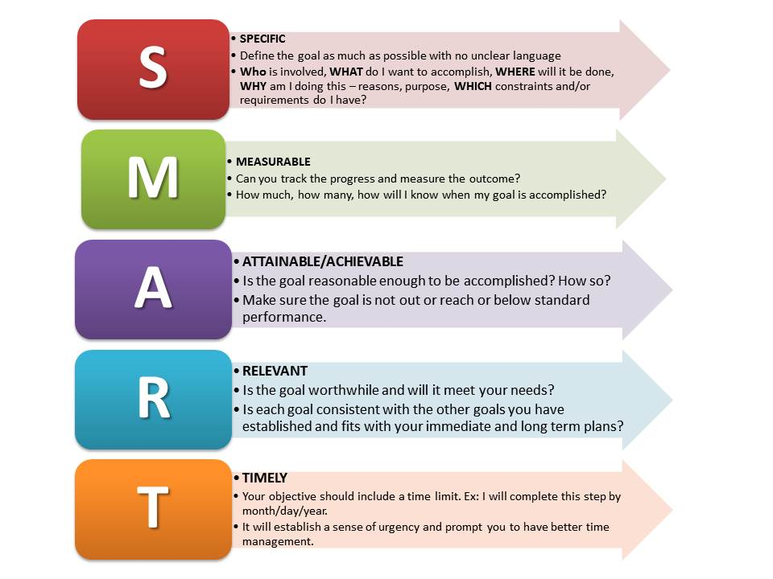

Resources Used:
- Check for Safety: A Home Fall Prevention Checklist for Older Adults (cdc.gov)
- Rebuilding Together (aota.org)

